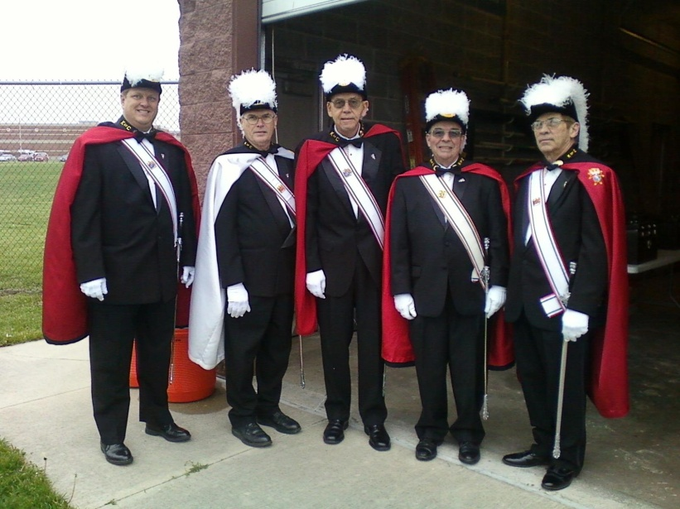
This Honor Guards one of many thru the Fraternail Year
This picture was taken
at Normal West Hight School
Additional pictures are of Officers of 2012-13
Seating are the Trustees
Dave Kraft—Bill Cunningham –- Jack Wilz
Standing left to right
Outside Sentinel—Terry Cochran
Navigator Dennis Fries
Southern Master Dean Salz
Comptroller Roger Petri
Purser Pat Chalmers
Inside Sentinel Rich Staley
Dean Salz presented the Assembly 0213 with a Cross as a gift

